***Assignment 4***

[***Order by and Group by Clause***](https://classroom.google.com/c/MTUwMTMxNjI0NjFa/a/MTUyOTQ3MjQ0MTJa/details)

***DBMS LAB***

**NAME-Ashish Goyal**

**ID-2016ucp1100**

**BATCH –A 1, 2**

1. Schema: custom (ID, NAME, AGE, ADDRESS, SALARY);

Describe table:

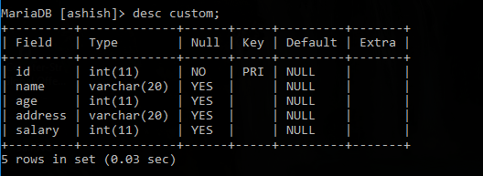

Content of table:

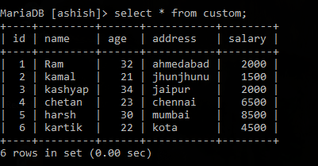

Query 1: Find the total amount of the salary on each customer;

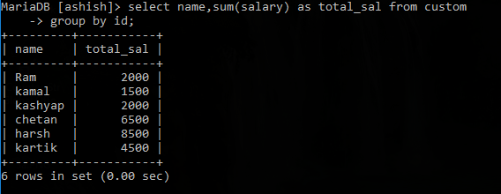

Query 2: Find the list of customers in chronological order by the NAME and the SALARY;

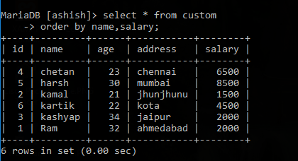

1. Schema:

Salesman (id,name,city,commission);

Customer (srno,name,city,grade,sales_id);

Orders (no,amount,date,cust_id,sales_id);

Here sales_id is a foreign key and refers to primary key "id" in Salesman table.

cust_id is a foreign key and refers to primary key "srno" in Customer table.

no is a primary key in Orders table.

Describe table:

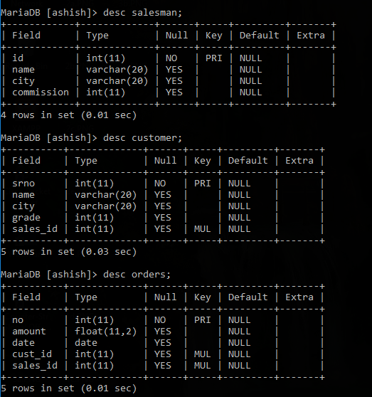

Content of table:

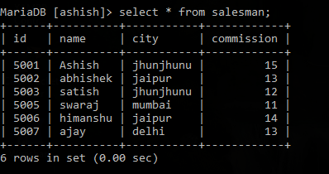

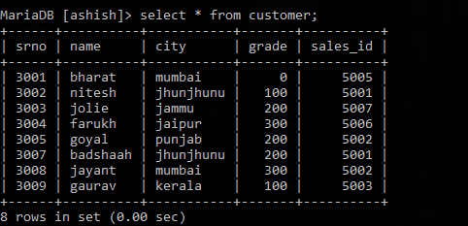

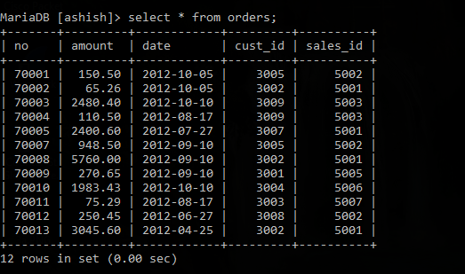

Query 1: Find the total no of orders served by all the salesman belonging to the same city.

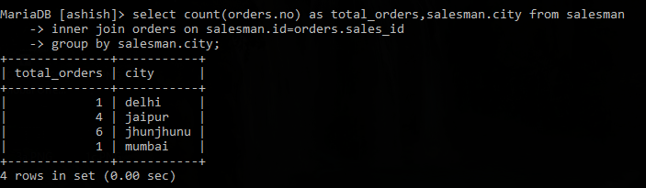

Query 2: Write a SQL statement to find the details of commission the salesman gets provided that his commission is more than or equal to the average commission in the city.

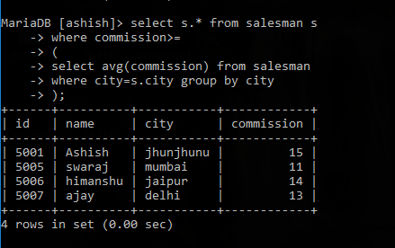

1. Schema: bookstore(bookid,year,month,volume,author,price);

Describe table:

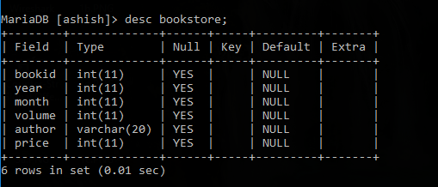

Content of table:

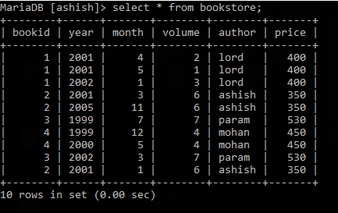

Query 1 : Calculate the total number of books sold each month. Order your results chronologically.

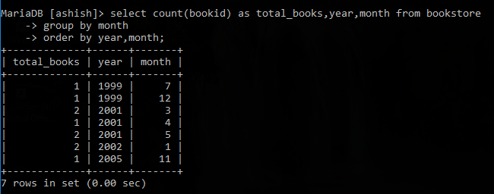

Query 2: Write a query that calculates the lowest and highest prices that store achieved each month.

